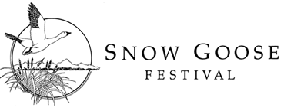
2017 VENDOR APPLICATION FORM

Important: Sales exhibit days are Saturday – Sunday, January 28th - 29th, 2017 at the Chico
Masonic Family Center, Chico, CA. Please read 2017 Snow Goose Festival Vendor Guidelines before submitting this form.

Cell phone:
Webpage: _____________________________ Organization Name:
Contact Person:
Address:
City/State/Zip: _______________________________ E-Mail:
Phone: _________________Selling Permit #_____________ Products_______________________

Type of Exhibit: We will have an 8’ X 18” table available for your sales exhibit, unless alternate arrangements are made. Space assignment will be made by Festival coordinators based on the information that you provide. The festival is open Saturday 9am-4pm and Sun 9am-3pm (check all that apply):

 | 8’ X 18” table |  | Alternate sales exhibit table request (explain below) |  | Free-Standing floor exhibit  (no table required)
 | Exhibit has displays on  both sides |  | Electricity Required |  | Need to be against a wall  (please list reason below)
Special Needs_______________________________________________________________________
Will there be someone present? Yes __ No__ Questions: email Prydelynne784@gmail.com

Vendor fees:
 | $100 (see Guidelines) |  | Sponsor (Tundra Swan $500 or higher sponsorship level)
Please sign below. send payment and completed registration form to:
Snow Goose Festival  P.O. Box 1063  Chico, CA 95927 |  | Payment may be made by check, VISA or Mastercard.  Credit Card:  Name on Card:  Card #:  Expiration: _________________ 3 digit code:

Authorized signature _____________________________ Date:

