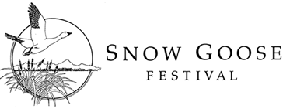
2019 EXHIBITOR APPLICATION FORM

Important: Exhibit days are Saturday – Sunday, January 26th - 27th, 2019, at the Chico Masonic Family Center, Chico, CA. Set up is Friday, January 25 Please read 2019 Snow Goose Festival Exhibitor Guidelines before submitting this form.

Organization Name:
Contact Person:
Address:
City/State/Zip: _______________________________ E-Mail:
Phone: _____________________________ Cell phone:
Webpage:
Character of Exhibit:

Type of Exhibit: We will have a 6’ X 30” table available for your exhibit. Space assignment will be made by exhibit coordinators based on the information that you provide. (check all that apply):

 | Table top exhibit (fits on 6’ or smaller table) |  | Table top exhibit requiring greater than 6’ table (please explain below) |  | Free-standing floor exhibit (no table required)
 | Exhibit has displays on both sides |  | Electricity required |  | Need to be against a wall (please list reason below)

Special Needs:
We would like to have someone at your exhibit to answer questions from 9:00 am - 4:00 pm on Saturday and Sunday from 9:00 am – 3 pm. Will there be someone present? Yes_____ No______

Exhibitor fees:
 | $45 |  | Sponsor (FREE-Tundra Swan or higher sponsorship level)

Please sign below. send payment and completed registration form to:
Snow Goose Festival, P.O. Box 1063, Chico, CA 95927 OR EMAIL TO INFO@SNOWGOOSEFESTIVAL.ORG
Name____________________________________________________________________________________
Card #____________________________________________________Security Code#______________
Expiration Date____________________Phone____________________________zip______________
email___________________________________________________________________________________
Signature______________________________________________________________________________

